## Group Members:

<<Individual Project>>

Rakshit Nautiyal

C19313276

TU856

## Domain Typess

|  |  |  |  |
| --- | --- | --- | --- |
| Domain Type Name | Type Definition | Reason Introduced | Example |
| Address | VARCHAR (50) | For attributes which are character-based address | address in Customer |
| Age | NUMERIC (3) | For attributes which represent small amounts like age | age in Customer |
| Time | TIMESTAMP | Date and time so that the time can be stored for attributes | time in BookingDetails |
| dob | DATE | Store date of attributes | dob in Manger and WaitingStaff |
| email | VARCHAR (40) | To store medium length character-based attributes | Email in Customer, Manager and WaitingStaff |
| identifier | NUMERIC (5) | Used for all numeric primary key identifiers | CustNum in customer |
| location | VARCHAR (10) | Smaller in size to preserve space where too many characters are not required. | Location in TableInfo |
| phone | NUMERIC (10) | Just to store exact 10 digits of a phone number | phoneNum in Customer |
| Name | VARCHAR (25) | To store attributes that contain name | Name in Manager |

## Major Decisions

**Entities and Attributes:**

**Branch:** branchId, address, phoneNum

**Customer:** customerNum, name, address, email, phone, age

**BookingDetails:** bookingId, time, numberOfPeople

**TableInfo:** tableId, location, type

**Manager:** id, name, address, email, phone, dateOfBirth, start date

**WaitingStaff:** id, name, address, email, phone, dateOfBirth, start date

**Fine:** TimeOut, fineDue

**ContactTracing:** **Will link all the data using foreign keys**

**Relationships:**

Fine 1:N Customer

Customer 1:N Booking

Customer 1:N ContactTracing

Manager 1:N ContactTracing

WaitingStaff 1:N ContactTracing

TableInfo 1:N ContactTracing

Branch 1:N WaitingStaff

Branch 1:N Manager

**Constraints:**

Check table types are 2,4,6 or 8.

Check staff email is like @burgershack.com.

Check table location interior or exterior

Unique email for staff.

**Primary Keys:**

**Branch:** branchId

**Customer:** customerNum

**BookingDetails:** bookingId

**TableInfo:** tableId

**Manager:** id

**WaitingStaff:** id

**Fine:** **foreign primary key**

**ContactTracing:** **foreign primary key**

**Decisions:**

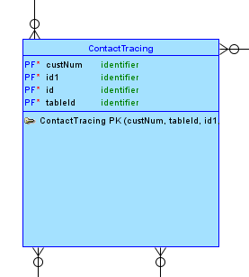

For contact tracing I used a centralized entity table and linked all the relevant entities to this ContactTracing entity. From entities like Customer, Manager, TableInfo and Waiting Staff.

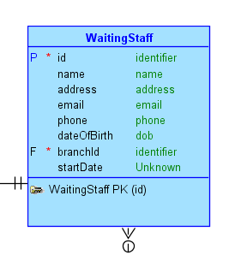 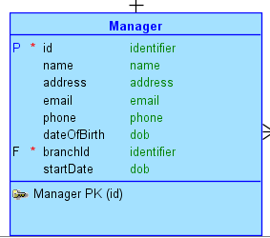

I seperated out staff table into a manager and a waitingStaff table so that when recording concatTracing it would be easier to assign a manager and a waiter at table.

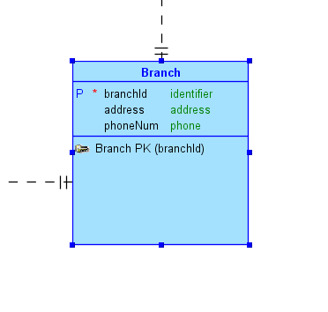

Linking the Manager and the Waiting Staff table is Branch table. I decided to use this table as link as all the staff comes under each restaurant branch.

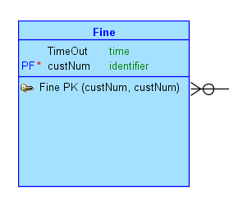

I also introduced the fine table which displays the fine that customers over for overstaying their visit for over 2 hours. This table was linked with the customer table so that the customer that owes a fine can be identified.

# Present ERD

Screenshot of Logical Model

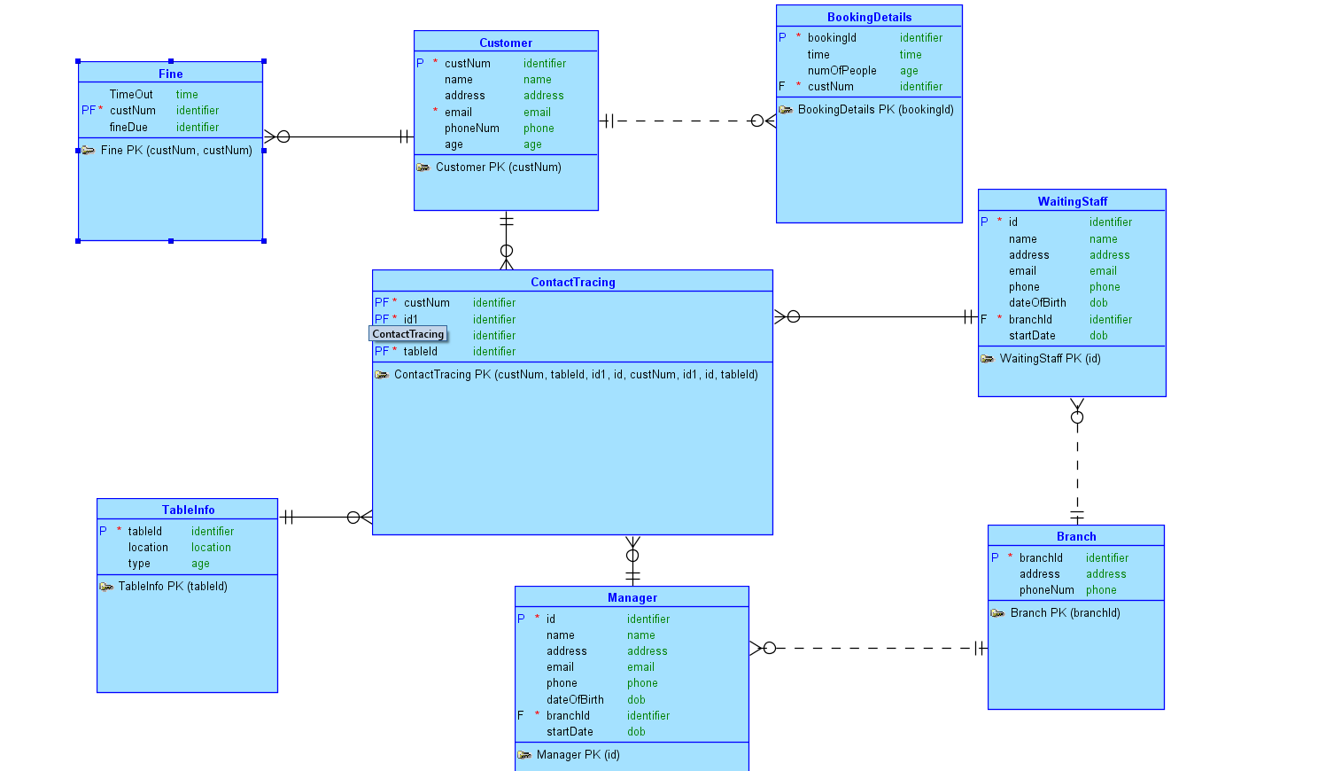

Screenshot of Physical Model

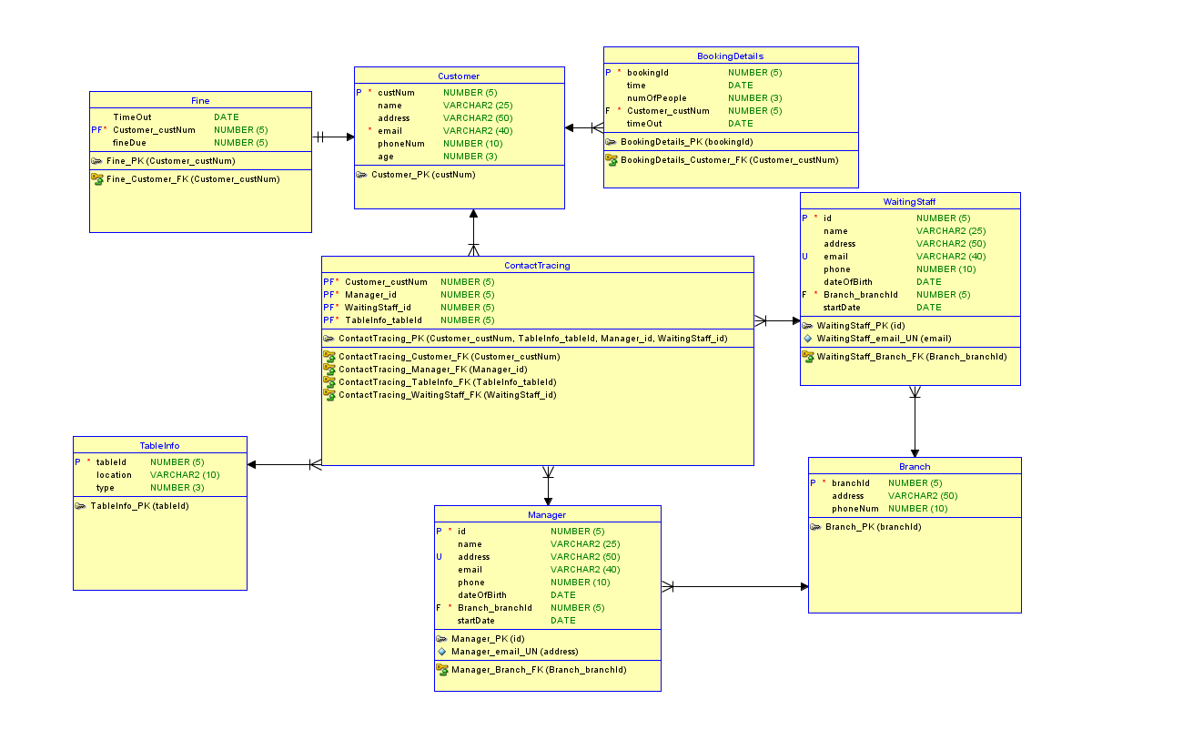

Screenshot of details that you have incorporated into your model such as unique or check constraints.

Unique Constraint

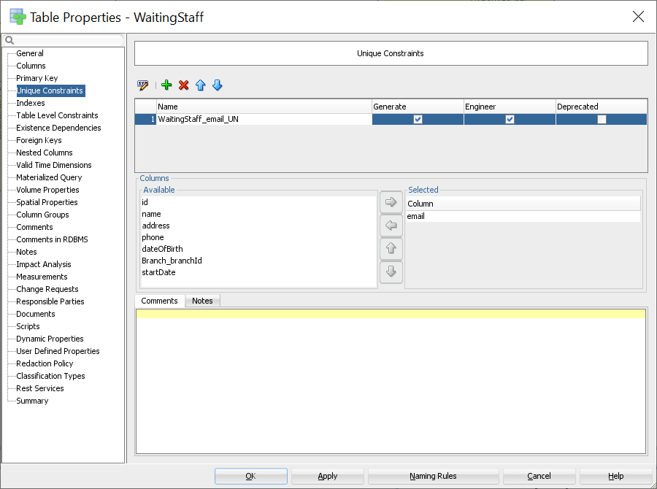

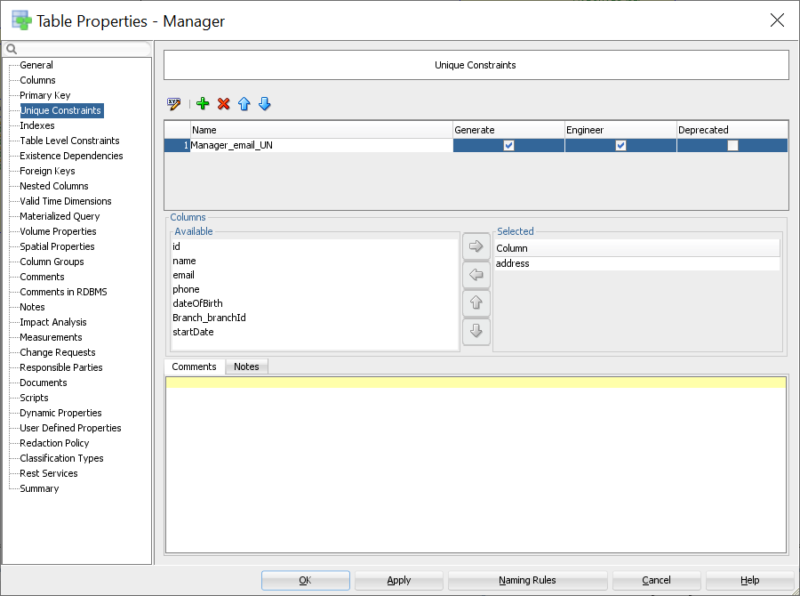

Check Constraints

